Daren Liu

March 12, 2021

Lab 8 Report

FIFO:

For FIFO, I used a current index counter that will cycle through the queue. Every time I want to add a page, I first check if the page exists already. If it doesn’t then I insert at the current index and increment the index. If there is already a page at the index, then that means the capacity is full. The new page would then overwrite the page at the index since it was the page that was added first. The sample hit-rate on accesses.txt with a cache size of 50 was 0.0485.

LRU:

For LRU, I used a current index counter and a timestamp for each page. When I try to add a page and find that it already exists in the cache, I update the timestamp, the number of requests and move on to the next iteration. If the page does not exist and the cache is full, I find the page with the smallest timestamp, since this is the page that is first accessed, and replace it with the new page and current number of requests as the timestamp. The sample hit-rate on accesses.txt with a cache size of 50 was 0.049.

Second Chance:

For Second Chance, I used a current index counter and a reference bit for each page. If I try to add a page and find it already exists, I set the reference bit to 1. If the page does not exist and the cache is full, I traverse the queue, setting all reference bits along the way to 0, from the current index until I find a page with a reference bit of 0 and replace that page. The sample hit-rate on accesses.txt with a cache size of 50 was 0.049.

|  | FIFO | LRU | Second Chance |
| --- | --- | --- | --- |
| 10 | 0.0084 | 0.0085 | 0.0085 |
| 50 | 0.0485 | 0.049 | 0.049 |
| 100 | 0.0982 | 0.0971 | 0.0978 |
| 250 | 0.2466 | 0.2468 | 0.2474 |
| 500 | 0.487 | 0.4794 | 0.4822 |

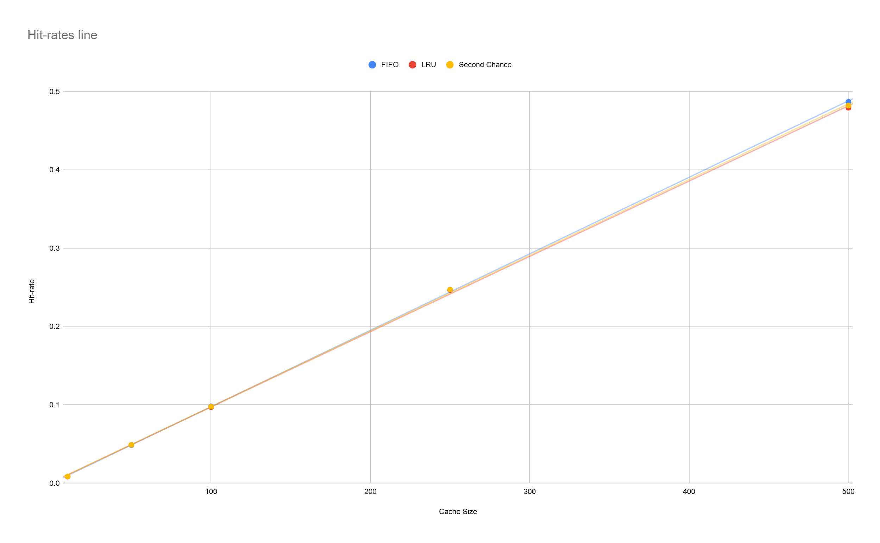

Step 6:

The hit-rate for testInput.txt was 0.3 for all algorithms.

Summary:

Overall, the difference in hit-rate between the algorithms is minimal. While the hit-rates started to diverge around a cache size of 100, the maximum difference, which is between FIFO and LRU, is still 0.0011. FIFO ended up with the highest hit-rate when the cache size is 500, but the difference with any cache size is still not significant.